Programming Project Report

Team 32

Hotel Management System

Members

Ahmed Ashraf Ali Ibrahim – 24P0405
Gerges Hany Ramsy Samy – 24P0393
Ziad Elnoby Shehto Taea Ismail – 24P0244
Omar Ehab Abouelfadl Ahmed Khalil – 24P0318

Contributions/Tasks
Gergers Hany | Log in/Log out and Dashboard menu & Full code merging and debugging
Omar Ehab | Display residents function, generate income reports function, calculate costs function, array initialization, receptionist dashboard debugging.
Ziad Elnoby | Resident Add/Edit/Delete , Assign room function receptionist dashboard debugging
Ahmed Ashraf | Structs creation, Worker Add/Edit/Delete functions , display worker and room monitoring functions

Screenshots of running code/Output(s)

Receptionist function
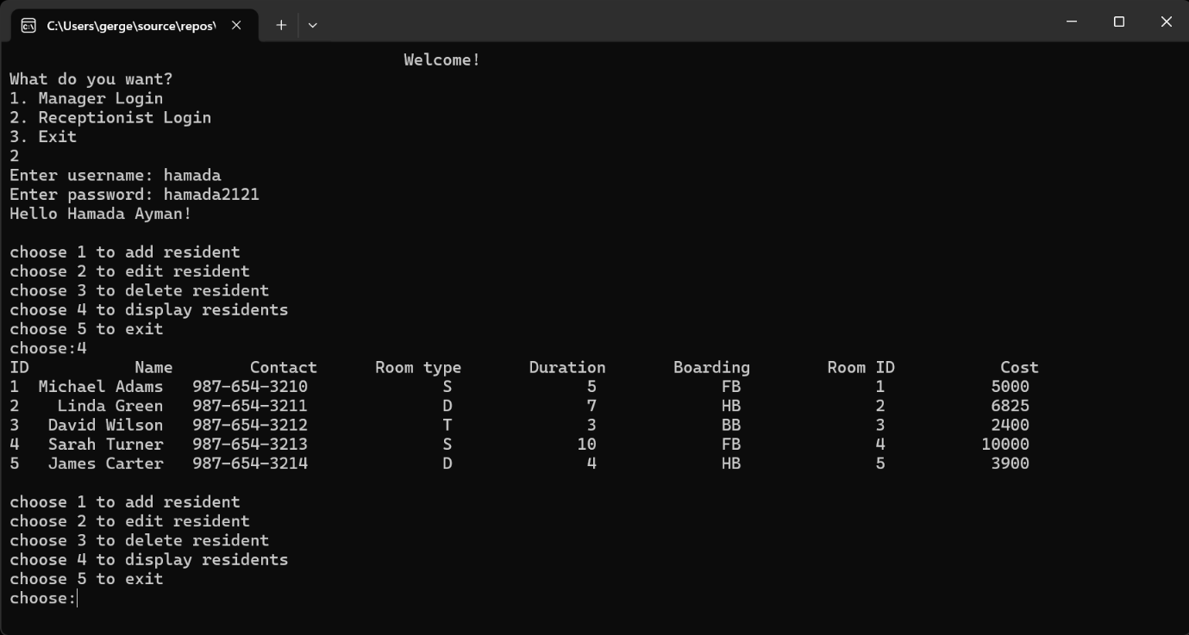

Worker function
